How to use Audit Office templates

## Getting started

Audit Service Providers are required to prepare all reports and formal correspondence with management and those charged with governance of the auditee using the Audit Office templates.

Always use the latest version of the Audit Office template when drafting a report/letter to ensure that the layout, formatting and information provided in the document are correct.

The latest version of Audit Office templates is available on the [Audit Office website](https://www.audit.nsw.gov.au/work-with-us/audit-service-providers/resources-for-audit-service-providers).

## Font usage

The Audit Office uses the font ‘Arial’ for all internally produced documents. To ensure optimal readability, the Audit Office uses Arial size 10 for body text and Arial size 9 for table text across all documents.

## Cover pages

Some Audit Office report templates contain front and back covers. The logos and images on these covers are locked in its place to prevent them from being accidentally moved or deleted. Update the name of the report, financial year end and name of the client.

|  |  |
| --- | --- |
| Front cover | Back cover |

## Headers, footers and page numbers

Headers, footers and page numbers are also locked in their respective places to prevent them from being accidentally moved or deleted.

## Address block

The address block should be on the left-hand side of the page, in line with the reference box. The suburb and state should always be in capital letters, with two spaces between the suburb, state, and postcode.

Client Name  
Address line 1  
Address line 2  
SYDNEY NSW 2000

## Styles

The Audit Office templates are in Word format and contain a set of styles to ensure uniformity across all official documents. These styles set the text type for different sections of the template and are used to differentiate a hierarchy of headings. Formatting is **limited** to permitted styles to prevent new styles from being imported.

To access styles:

* Click the dialog box launcher in the styles group on the Home tab to open the Styles task pane (it can also be opened with the keyboard shortcut Alt+Ctrl+Shift+S).  
  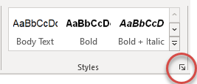

To apply styles:

* Select the text you want to format.  
  **Tip**: If you place your cursor in a paragraph, the style is applied to the whole paragraph. If you select specific text, only the selected text is formatted.
* Select a style from the styles pane.
* Always refer to the relevant template on the website for the correct styles used.

To highlight selected text:

* Select the text to highlight.
* Select the Highlight style from the styles pane.

To remove highlighting from selected text:

* Select the text from which you want to remove the highlighting.
* Select ‘Clear All’ from the list of styles in the styles pane. The highlight style applied to the selected text will be removed.
* Apply the correct style to the selected text if necessary.

## Autofill text fields

The Audit Office templates contain autofill text fields, where text entered in one place are automatically repeated throughout the whole document. Autofill text fields are a great way to reduce errors and save time when drafting reports/letters since the relevant text will only be entered once rather than manually entering the same text into every place it is needed.

To use the autofill text fields:

1. Update the wording inside the highlighted text field. Do not delete the text field.  
   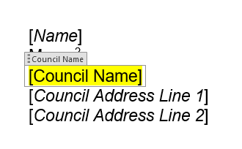
2. Once updated, click anywhere outside the text field. All fields with the same properties in the document (not highlighted) will be automatically populated with the same text.  
   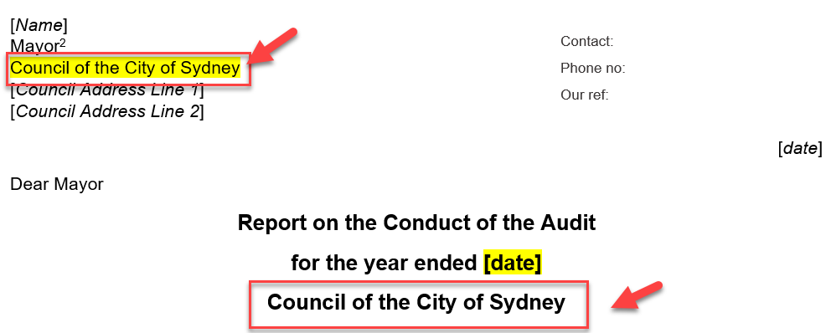
3. For fields that contain dates, click on the drop-down arrow to select the correct date. This will automatically display the date in the correct format.  
   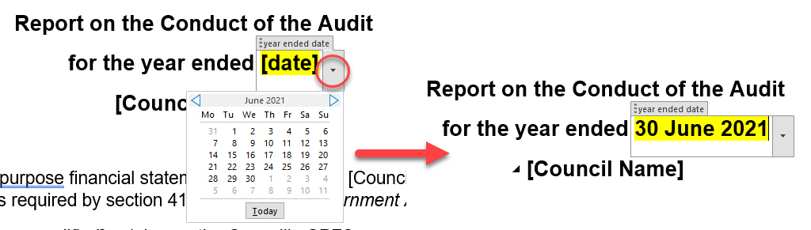
4. To remove the highlight, select the highlighted text field.  
   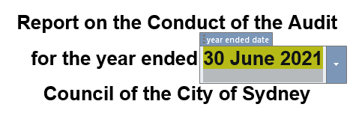
5. Select ‘Clear All’ from the list of styles in the styles pane to clear all formatting.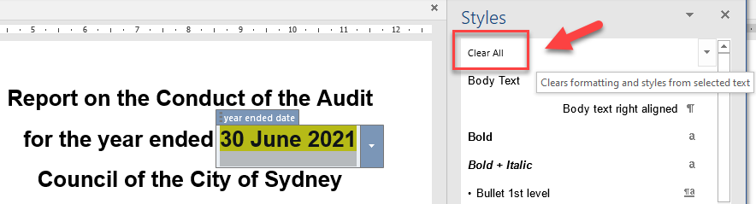
6. Apply the correct style to the selected text field.  
   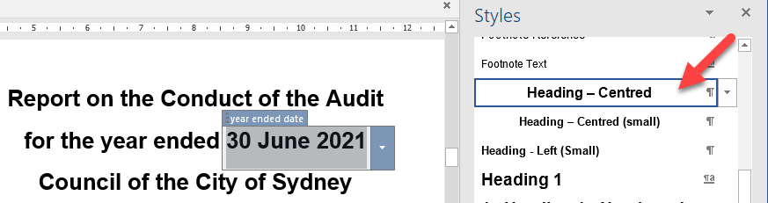

## Section breaks

The Audit Office templates use section breaks so different parts of the template can have its own layout and formatting. These section breaks are locked in its place to prevent them from being accidentally deleted, except for the section break following the instructions page at the beginning of the template. This section break, along with the instructions, will be deleted before the document is finalised.

Please be mindful not to delete section breaks if working on a template with unlocked section breaks. When you delete a section break, Word combines the text before and after the break into one section and the new combined section will use the formatting from the section that followed the deleted section break. Click on the show/hide formatting mark button when working on a document to see where section breaks are in the template.

Show/hide formatting

## Bulleted and numbered lists

Apply the relevant bulleted/numbered list style from the styles pane. Always introduce the list with a colon and ensure there is a full stop:

* after the final point
* after each point in bulleted/numbered lists that contain full sentences.

## Tables

The tables in the templates have already been formatted. Turning on the table gridlines will help you see the boundaries and make it easier to add text and numbers inside a table. To format the text inside a table, apply the relevant table styles from the styles pane. Always refer to the template on the website for the correct styles used.

If a table spans multiple pages, the header rows should appear on every page for easy reference. A table can be set up so that the table header row or rows appear on each page automatically.

**To repeat table header(s) on subsequent pages:**

* 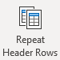Select the header row or rows that you want to repeat on each page. The selection must include the first row of the table.
* Under Table Tools, on the Layout tab, in the Data group, click Repeat Header Rows.

## Hyperlinks

Audit Office templates contain hyperlinks that allow users to quickly access specific sections of the report marked with a heading style or bookmark. Headings are automatically marked as a destination if one of the built-in heading styles is applied. Bookmarks for specific sections of the report have already been added to the template.

Ensure hyperlinked references correctly link to the relevant section of the report. Amend/update section references where:

* extra sections are added
* sections are removed.

**To insert a bookmark:**

* Click where you want to insert a bookmark.
* Click Insert > Bookmark.  
  
* Under Bookmark name, type the name of the section.  
  **Note**: Bookmark names need to begin with a letter. They can include both numbers and letters, but not spaces. If you need to separate words, you can use an underscore - for example, ‘Audit_outcome’.

**To add a hyperlink:**

* Right click on the selected reference and select ‘Link’.
* Click on ‘Bookmark’
* Select the relevant section name and click ‘OK’.

**To update a hyperlink:**

* Right click on the selected reference and select ‘edit hyperlink’.
* Select the relevant section name.
* Update ‘Text to display’ and click ‘OK’.

## Graphs

The graphs in the templates have been formatted. The only change that needs to be made is to add the figures and, if required, re scaling of the vertical axis.

To update the graph:

* Click on the graph.
* In the ‘Design’ ribbon click on ‘**Edit data in Excel**’
* An Excel spreadsheet will appear with the data in the graph.
* Replace the dummy data with the actual figures.
* Click outside the last cell entered and then close Excel by clicking on the top right-hand corner.
* Right click on the vertical axis and select ‘Format Axis’.
* For the Axis options (minimum and maximum bounds and units), click the ‘Reset’ button. They should say ‘Auto’ after clicking the buttons.

## Table of Contents

Update table of contents once the draft report is complete.

To update table of contents:

* Click on the table of contents to highlight the whole area. You will see that the whole area becomes greyed out.
* Right click to bring up the table of contents menu. Click on ‘Update Field’.
* Click on ‘Update entire table’ to update both headings and page numbers.

## Review

Send draft engagement deliverables (using the Audit Office template) to the Audit Office Engagement Controller to review, sign and issue.