Local government financial reporting issues and developments
Application
Type of audit and assurance work | Type of entities
- This document applies to financial statements (general purpose) audit engagements. | - local and county councils (councils)  - joint organisations (JOs)  - council entities (where applicable).
Instructions
Auditors should refer to the Financial Reporting Issues and Developments in the Annual Engagement Plan (AEP).
Objective
This template summarises current issues and recently issued professional and statutory requirements that may affect the financial statements and/or annual report.
Documentation
The AEP template contains a link to this document. It does not need to be filed in the audit file as it is issued to the auditee via the Audit Office website. However, where this document refers to a matter of significance to a council or JO, the information may, with appropriate tailoring be highlighted within the AEP.
Background
This document includes:
- current issues and financial reporting developments that may impact councils’ and JOs’ financial statements
- Australian Accounting Standards Board pronouncements issued between 1 January 2019 to 2 December 2019
- other pronouncements issued between 1 January 2019 to 2 December 2019 that may have a direct/indirect impact on the financial statements and/or annual report.

Financial
reporting issues
and developments

Local Government

December 2019

contents

Financial reporting issues and developments 1
Future reporting developments 1
Other new financial reporting pronouncements 6
Australian Accounting Standards 6
Office of Local Government (OLG) publications 8

Financial reporting issues and developments
The table below details current issues and financial reporting developments that may impact your council’s/joint organisation’s (JOs) financial statements. Management should review these issues and developments, determine those applicable to the council/JO and assess the impact on the financial statements and annual report. Where this relates to an accounting standard issued but not yet effective, management should disclose the anticipated impact of the standard in their financial statements. Management may consult their audit team for further information and explanation on the issues and developments detailed below.
Councils/JOs should refer to the Office of Local Government’s (OLG) Code of Accounting Practice and Financial Reporting for mandates on accounting policy options and major policy decisions under Australian Accounting Standards when determining if an accounting standard can be early adopted.
The issues below apply to all entities, where applicable.

Future reporting developments
Issue 1: AASB 15 ‘Revenue from Contracts with Customers’ and AASB 1058 ‘Income of Not-for-Profit Entities’
Overview | Applies to
AASB 15 ‘Revenue from Contracts with Customers’
In December 2014, the AASB issued a new standard AASB 15 ‘Revenue from Contracts with Customers’.  AASB 15 introduces a new five step-model for recognising revenue based on the principle that revenue is recognised when control of a good or service transfers to a customer. It will impact councils/JOs providing goods or services under contract arrangements, especially those offering bundled products and services, providing warranties or rebates, or contracts with variable consideration.  In May 2016, AASB 2016-3 ‘Amendments to Australian Accounting Standards – Clarifications to AASB 15’ amended AASB 15 to:  - clarify the requirements for identifying performance obligations, principal versus agent considerations and the timing of revenue recognition from granting a licence  - provide further practical expedients on transition to AASB 15.  The impact of AASB 15 on not-for-profit (NFP) entities should be considered in conjunction with the requirements in AASB 1058 (refer below). | For-profit entities for annual reporting periods beginning on or after 1 January 2018  Not-for-profit entities for annual reporting periods beginning on or after 1 January 2019
AASB 1058 ‘Income of Not-for-Profit Entities’
AASB 1058 applies to:  - transactions where consideration to acquire an asset is significantly less than fair value, principally to enable a NFP entity to further its objectives  - receipt of volunteer services.  On initial recognition of an asset an entity must recognise any related contributions by owners, increases in liabilities, decreases in assets and revenue (‘related amounts’) in accordance with other Australian Accounting Standards.  Entities must immediately recognise the difference between the fair value of the asset and any related amounts as income in the profit and loss. However, if the transaction enables the entity to acquire or construct a recognisable non-financial asset controlled by the entity (i.e. an in-substance acquisition of a non-financial asset), the entity may recognise income as it satisfies its obligations under the transfer (similar to income recognition for performance obligations under AASB 15).  A transfer of a financial asset to acquire or construct a recognisable non-financial asset controlled by the entity is one that:  - requires the entity to use that financial asset to acquire or construct a recognisable non-financial asset to identified specifications  - does not require the entity to transfer the non-financial asset to the transferor or other parties  - occurs under an enforceable agreement.  Local governments, government departments, general government sectors (GGSs) and whole of governments must recognise volunteer services if:  - they would have been purchased if not provided voluntarily  - the fair value of those services can be measured reliably.  For-profit entities will continue to account for grants and contributions under AASB 120 ‘Accounting for Government Grants and Disclosure of Government Assistance’.  Full or modified retrospective application is required on initial adoption of AASB 1058. The transitional provisions include practical expedients for completed contracts and assets acquired for consideration significantly less than fair value principally to enable the entity to further its objectives.  Practical examples accompany AASB 1058 demonstrating how a NFP entity applies the requirements in practice.  OLG has released guidance on the financial reporting options councils/JOs must elect on transition to AASB 15 and AASB 1058. The guidance mandates:  - the adoption of the modified retrospective approach on transition  - the practical expedients that must/must not be applied on transition  - the ongoing options within AASB 15 and AASB 1058 that must/must not be applied. | NFP entities for annual reporting periods beginning on or after 1 January 2019
Council responsibilities
To effectively implement AASB 15 and AASB 1058 councils/JOs will need to have:
- an understanding of the new requirements and authoritative implementation guidance published by the AASB
- considered whether AASB 15 and AASB 1058 will change their income recognition policies. If it does, the impact needs to be disclosed before the application date, as ‘modified’ retrospective application will be required on adoption
- assessed and ensured registers/databases of contracts with customers are complete and identify performance obligations within the contracts
- assessed and ensured grants registers/databases are complete and identify whether the transaction enabled the council/JO to acquire or construct a recognisable non-financial asset controlled by the council/JO
- prepared for significantly increased disclosures
- reviewed standard contract templates to ensure new contracts clearly support revenue recognition with the goods and services sold
- assessed whether existing systems support income recognition and are capable of capturing the key information requirements of the new standards and updated existing or implemented new systems, where required
- ensured the control environment supports robust estimates and judgements on income recognition
- considered the impact on reporting to stakeholders regarding the council’s/JO’s financial position and performance
- planned and conducted training for accounting staff, legal and sales teams
- advised customers and other stakeholders if changes will be made to contracts, systems and processes
- provided proper guidance to ARICs
- discussed proposed income recognition policies and financial statement disclosures with their ARICs and auditors
- referred to the guidance released by OLG for the options within AASB 15 and AASB 1058 they must adopt on transition

Responsibilities of Audit, Risk and Improvement Committees and those charged with governance
ARICs and those charged with governance should:
- understand AASB 15 and AASB 1058
- ensure management has adequately planned and implemented AASB 15 and AASB 1058, including disclosing the impact in the current year’s financial statements.

Issue 2: AASB 16 ‘Leases’
Overview | Applies to
In February 2016, the AASB issued a new standard: AASB 16 ‘Leases’.  AASB 16 eliminates the need for lessees to classify leases as either operating leases or finance leases. Leases will be ‘capitalised’ by recognising the present value of the future lease payments. Preparers can present leased assets in their financial statements in a separate category as leased (right-of-use) assets, or together with the property, plant and equipment category.  Lessees will recognise a financial liability for their obligation to make future lease payments. The principal and interest portions of the cash payments will be separately disclosed in the Statement of Cash Flows.  Lessees are not required to recognise assets and liabilities for:  - short-term leases of 12 months or less  - leases of low-value assets.  The new requirements will significantly increase right of use assets and related financial liabilities on lessees’ balance sheets.  Lessor accounting requirements are substantially carried forward from AASB 117 ‘Leases’. Accordingly, lessors will continue classifying leases as operating leases or finance leases, and accounting for them differently.  Reporting entities will not have to restate comparative information when first applying AASB 16. On initial recognition, entities can choose how to measure leased assets that were previously off-balance sheet. Leased assets can be measured as if AASB 16 had always applied, or at an amount based on the lease liability.  OLG have released guidance on the financial reporting options councils/JOs must elect on transition to AASB 16. The guidance mandates:  - the adoption of the modified retrospective approach on transition  - the practical expedients that must/must not be applied on transition  - the ongoing options within AASB 16 that must be applied. | Councils, JOs and council entities for annual reporting periods beginning on or after 1 January 2019
Council/JO responsibilities
To effectively implement AASB 16 councils/JOs will need to have:
- an understanding of the new requirements and authoritative implementation guidance published by the AASB
- considered whether the standard will change their accounting policies for leases. The impact must be disclosed before the application date, as ‘modified’ retrospective application will be required on adoption
- assessed and ensured registers/databases of leases are complete
- assessed whether existing systems can capture information requirements of the new standard, and updated existing or implemented new system, where required
- prepared for the increased disclosures
- considered the impact on reporting to stakeholders regarding the council’s/JO’s financial position and performance
- planned and conducted training for accounting and legal staff
- provided proper guidance to ARICs
- discussed proposed lease policies and financial statement disclosures with their ARICs and auditors
- referred to the guidance released by OLG for the options within AASB 16 they must adopt on transition.

Responsibilities of Audit, Risk and Improvement Committees and those charged with governance
ARICs and those charged with governance should:
- understand the new standard
- ensure management has adequately planned and implemented AASB 16 including disclosing the impact in the current year financial statements.

Issue 3: AASB 1059 Service Concession Arrangements: ‘Grantors’
Overview | Applies to
In July 2017, the AASB issued a new accounting standard: AASB 1059 ‘Service Concession Arrangements: Grantors’ to address the gap in accounting for service concession arrangements (SCAs) from the grantor’s perspective.  AASB 1059 applies to arrangements involving an operator providing public services related to a service concession asset on behalf of a public-sector grantor for a specified period of time and managing at least some of those services. Common examples include roads, prisons, hospitals, water distribution facilities and energy supply.  AASB 1059 will affect all public sector entity grantors (both for-profit and not-for-profit) involved in SCAs (including grantors of existing, but unrecognised SCAs).  AASB 1059 requires a grantor to:  - recognise an asset provided by the operator (including an upgrade to an existing asset of the grantor) as a service concession asset if the grantor controls the asset. The grantor controls the asset if they:  - control or regulate the services the operator must provide with the asset, to whom it must provide them and at what price, and  - control either a significant residual interest in the asset at the end of the arrangement, or control the asset for the whole of the life arrangement  - reclassify an existing asset (including recognising previously unrecognised identifiable intangible assets and land under roads) as a service concession asset when it meets the conditions specified above  - initially measure the service concession asset at current replacement cost (CRC) in accordance with AASB 13 ‘Fair Value Measurement’. After initial recognition or reclassification, account for the service concession asset in accordance with AASB 116 ‘Property, Plant and Equipment’ or AASB 138 ‘Intangible Assets’, as appropriate, except as specified in this standard  - recognise a corresponding liability measured initially at the fair value (CRC) of the service concession asset, adjusted for any other consideration between the grantor and the operator; using either or both models (financial liability, or grant of a right to the operator) specified in the standard  - disclose sufficient information to enable users of financial statements to understand the nature, amount, timing and uncertainty of assets, liabilities, revenue and cash flows arising from SCAs.  Grantors must apply AASB 1059 retrospectively:  - to each prior period presented under AASB 108 ‘Accounting Policies, Changes in Accounting Estimates and Errors’, or  - by recognising and measuring service concession assets and related liabilities at the date of initial application (being the beginning of the earliest comparative reporting period presented). | All public-sector entity grantors for annual reporting periods beginning on or after 1 January 2020, with early adoption permitted
Council responsibilities
Councils should:
- understand the requirements of the new standard and authoritative implementation guidance published by the AASB
- assess the terms and conditions of existing arrangements with private sector operators to assess whether they fall within the scope of AASB 1059 and meet the criteria for recognition as a SCA or whether they are a leasing or outsourcing arrangement
- discuss their assessment with the ARIC and auditors
- consider the impact of this issued, but not yet effective standard and make appropriate disclosures under AASB 108 ‘Accounting Policies, Changes in Accounting Estimates and Errors’
- if an arrangement falls within the scope of AASB 1059, develop an implementation plan to apply AASB 1059.

Responsibilities of Audit, Risk and Improvement Committees and those charged with governance
ARICs and those charged with governance should:
- understand the new standard
- review management’s assessment of whether any current arrangements fall within the scope of AASB 1059
- if an arrangement falls within the scope of AASB 1059:
  - ensure management has adequately planned for its effective application, including disclosure of the impact in the current year financial statements
  - monitor progress against the plan and the requirements of the standard.

Other new financial reporting pronouncements
The following pronouncements, which may affect councils and their controlled entities’, and JOs’ financial statements and/or annual reports, were issued between 1 January 2019 and 2 December 2019.
The table below does not include accounting standards issued during the period if an overview has already been provided in the table above.

Australian Accounting Standards
Reference/Title | Effective date | Standards amended/replaced
2019-1 ‘Amendments to Australian Accounting Standards – References to the Conceptual Framework’
This Standard amends Australian Accounting Standards, Interpretations and other pronouncements to:  - reflect the AASB’s issue of the new ‘Conceptual Framework for Financial Reporting (new Conceptual Framework)’  - permit other entities to continue using the ‘Framework for the Preparation and Presentation of Financial Statements’ adopted by the AASB in 2004 and Statement of Accounting Concepts SAC 1 ‘Definition of the Reporting Entity’ to determine whether they are a reporting entity that needs to prepare general purpose financial statements that comply with Australian Accounting Standards.  Application of the new Conceptual Framework is presently limited to:  - for-profit private sector entities that have public accountability and are required by legislation to comply with Australian Accounting Standards; and  - other for-profit entities that voluntarily elect to apply the Conceptual Framework, which would permit compliance with Australian Accounting Standards (Tier 1) and International Financial Reporting Standards. | Annual reporting periods on or after 1 January 2020, with early application permitted | Various
2019-2 ‘Amendments to Australian Accounting Standards – Implementation of AASB 1059’
This Standard amends AASB 1059 ‘Service Concession Arrangements: Grantors’ to:  - change the modified retrospective approach set out in AASB paragraph C4 to:  - specify the financial liability should be recognised at the date of initial application;  - amend the method for measuring the liability under the Grant of a Right to the Operator (GORTO) model;  - specify the method for measuring the liability where the operator has provided additional consideration for access to an existing asset of the grantor  - make editorial amndments to the accompanying application and implementation guidance.  This Standard also amends AASB 16 ‘Leases’ to provide a practical expedient to grantors of service concession arrangements so that AASB 16 would not need to be applied to assets that would be recognised as service concession assets under AASB 1059. | Annual reporting periods on or after 1 January 2020, with early application permitted | AASB 16 and AASB 1059
2019-3 ‘Amendments to Australian Accounting Standards – Interest Rate Benchmark Reform'
The Standard amends AASB 7, AASB 9 and AASB 139 to modify some specific hedge accounting requirements to provide relief from the potential effects of the uncertainty caused by the interest rate benchmark reform. In addition, the amendments require entities to provide additional information about their hedging relationships that are directly affected by these uncertainties. | Annual reporting periods on or after 1 January 2020, with early application permitted | AASB 7, AASB 9 and AASB 139
2019-5 ‘Amendments to Australian Accounting Standards – Disclosure of the effect of new IFRS Standards not yet issued in Australia’
This Standard amends AASB 1054 ‘Australian Additional Disclosures’ to add a disclosure requirement for an entity intending to comply with IFRS Standards to disclose the information specified in paragraphs 30 and 31 of AASB 108 ‘Accounting Policies, Changes in Accounting Estimates and Errors’ on the potential effect of an IFRS Standard that has not yet been issued by the AASB. | Annual reporting periods on or after 1 January 2020, with early application permitted | AASB 1054

Office of Local Government (OLG) publications
Council circulars and guidelines – refer to OLG website
19-28 ‘Annual Report and Annual Performance Statement Checklists’
19-27 ‘Extension of the rates path protection for new councils’
Guidelines for the preparation of an application to increase minimum rates above the statutory limit for 2020-21
Guidelines for the preparation of an application for a special variation to general income for 2020-21
19-22 ‘Government response to IPART’s review of local government election costs’
19-18 ‘Calendar of Compliance and Reporting Requirements 2019-20’
19-15 ‘End of Year Financial Reporting 2018-19’
19-14 ‘Recent amendments to the Local Government Act 1993’
19-11 ‘Release of IPART Reports into rating and compliance matters for consultation’
Circular GC 148 ‘2019-20 Financial Assistance Grants (FAGs) – advance payment and on-going transition to implement improvements to the existing allocation model’
19-07 ‘2019/20 Determination of the Local Government Remuneration Tribunal’
19-06 ‘Changes to emergency services funding arrangements’
19-05 ‘Information about Rating 2019-20’
19-01 ‘NSW Parking Fine – Grace Period Provisions’

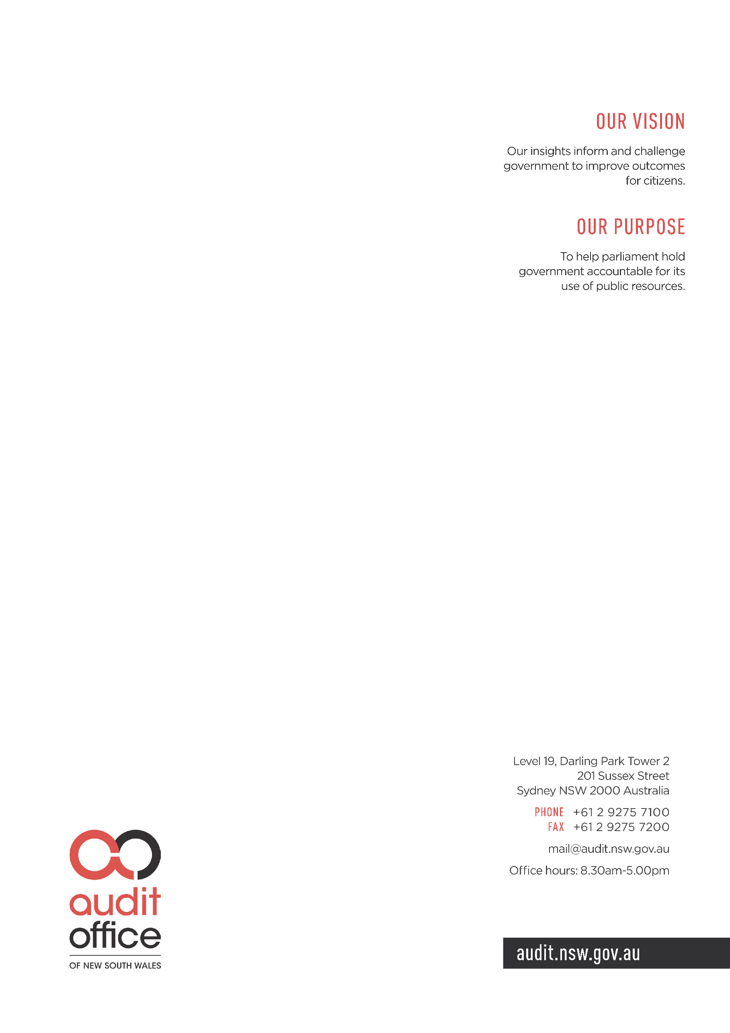

The functions of the Office of Local Government are within the Department of Planning, Industry and Environment.
OLG has provided guidance on the threshold for low value assets to be in the region of AUD 7,000 – AUD 10,000 but no higher than AUD 10,000.
AASB 2018-5 ‘Amendments to Australian Accounting Standards – Deferral of AASB 1059’ amends AASB 1059 to defer its effective date from annual reporting periods beginning on or after 1 January 2019 to 1 January 2020.
Note this table only includes new standards issued and excludes compiled standards issued.

